FOR IMMEDIATE RELEASE

MEDIA CONTACTS
Danielle Smith | danielle@frameworksf.com
Kimberly Verde | kv@frameworksf.com

Be Not Still: Living in Uncertain Times investigates our social and political terrain through a new institution-wide artist-driven initiative at di Rosa

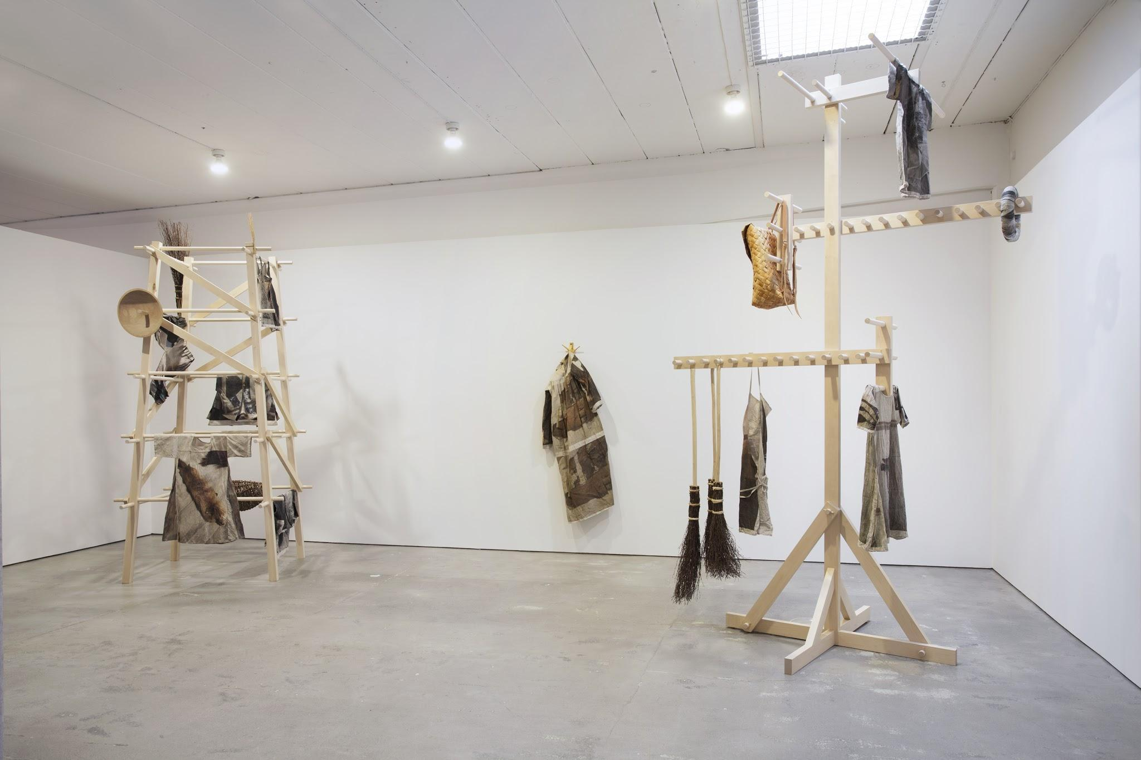
Allison Smith, The Fort (installation view), 2015. Courtesy of the artist and Signal Center for Contemporary Art, Malmo, Sweden. Photo: Lotten Pålsson

Be Not Still: Living in Uncertain Times
November 4, 2017 - January 2019
Part I: November 4, 2017 - May 27, 2018
Dodie Bellamy & Kevin Killian, Ala Ebtekar, Rigo 23, and Allison Smith

Part II: Opens June 2018
Additional programming and artists to be announced
dirosaart.org

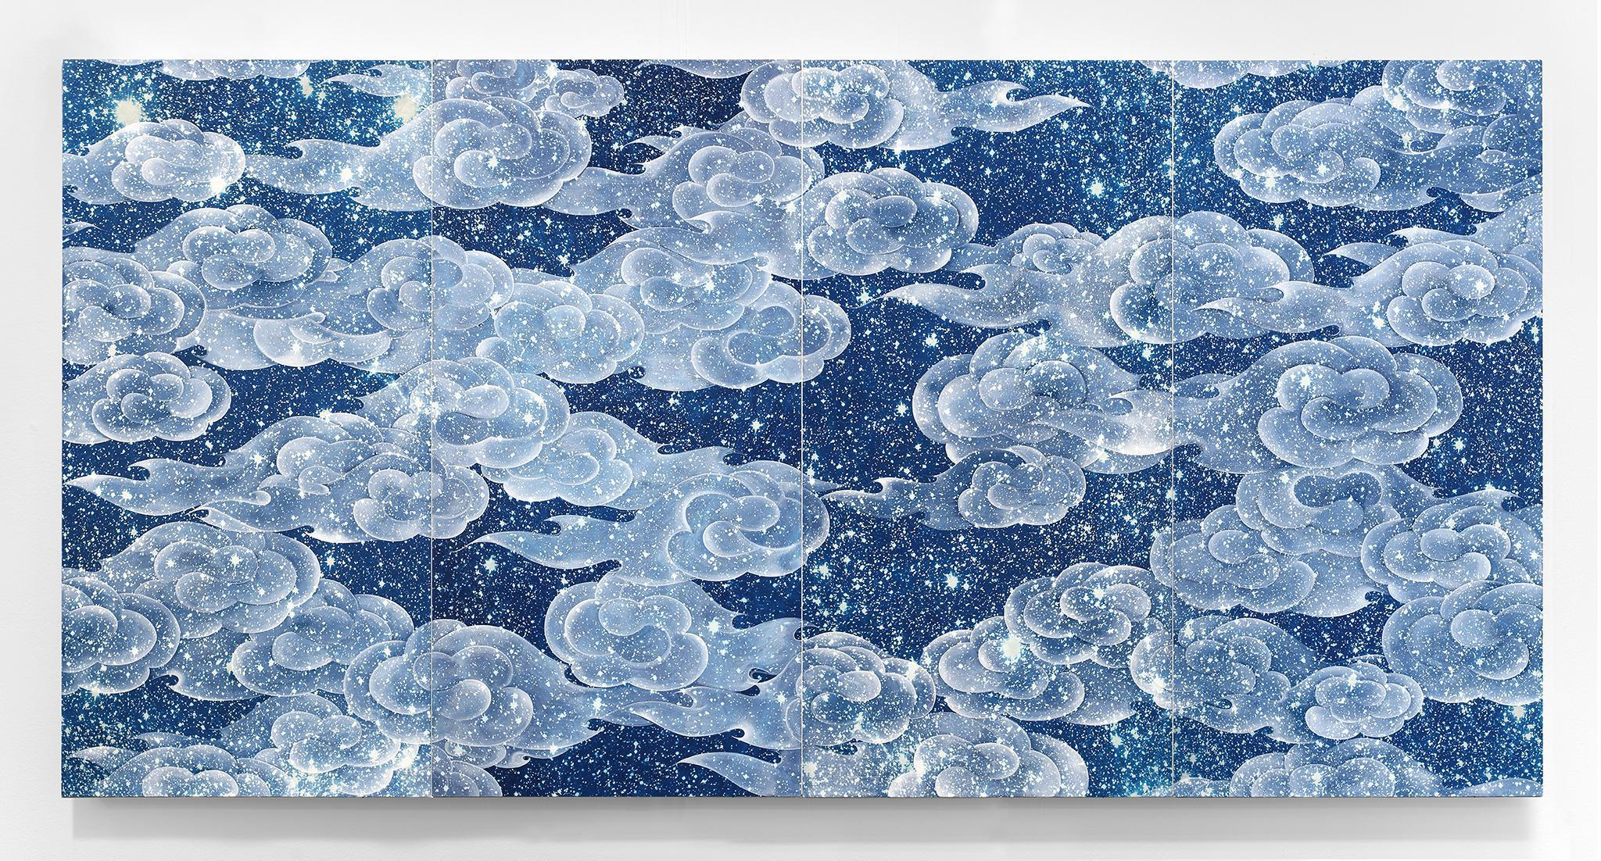
* Updated, August 8, 2017

Napa, Calif., July 6, 2017一
di Rosa announces a new campus-wide initiative with its next exhibition, Be Not Still: Living in Uncertain Times. Unfolding in two parts over the course of 2017 and 2018, the exhibition invites artists to create new work and utilize di Rosa’s collection to engage viewers in critical questions and concerns of their choosing in response to our current political and social atmosphere. Drawing upon the regional and global relevance of di Rosa’s permanent collection and the legacy of di Rosa’s founder, Rene di Rosa, the exhibition emphasizes an institutional focus on supporting living artists and inaugurates an ongoing endeavor to engage audiences in ideas that matter. Central to Be Not Still is an extensive education and civic engagement program including community partnerships and artist residency projects. Speaking about the timing and rationale for the exhibition, Executive Director Robert Sain states, “this is a compelling moment to investigate what a center for contemporary art can and should be in the 21st century and di Rosa is poised to spearhead new ways of thinking about the role of art in contemporary society not only through this exhibition but through a holistic re-envisioning of the institution.”
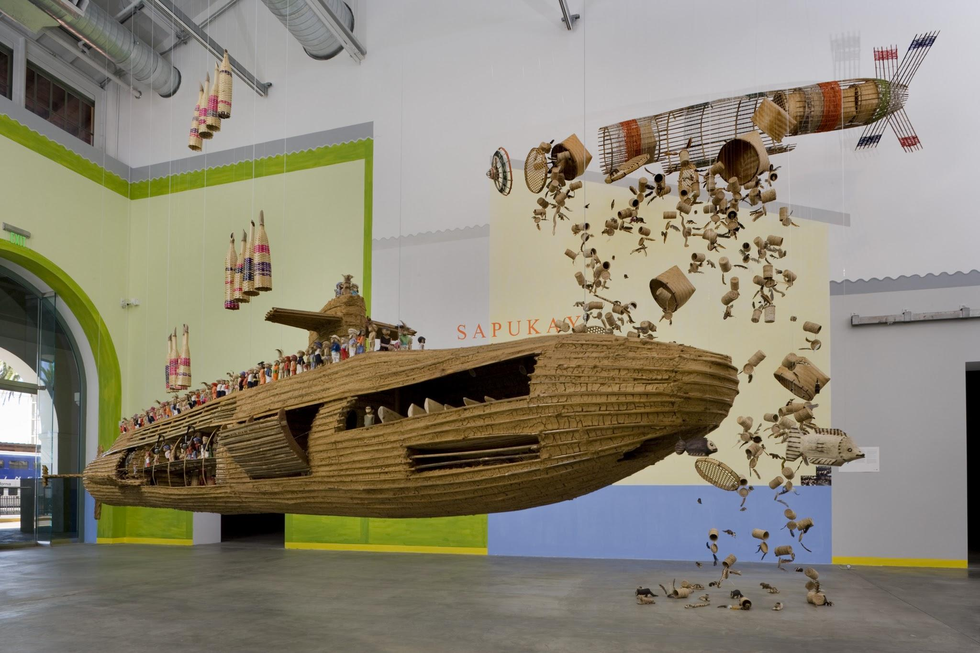
Part 1: November 4, 2017 – May 27, 2018
Ala Ebtekar, Rigo 23, and Allison Smith will each present new installations responding to, respectively, citizenship, American exceptionalism, and North American fundamentalism in di Rosa’s 8,500 ft² Main Gallery. di Rosa’s 3,000 ft² Gatehouse Gallery will feature an installation of work from the permanent collection curated by Dodie Bellamy and Kevin Killian organized around the topic of surveillance.

“Part 1 of Be Not Still represents a broad approach to powerful and provocative forms of artistic production and social engagement that share multiple affinities with the artists that Rene di Rosa had an abiding interest in supporting,” says Curator Amy Owen. “di Rosa provided financial support to artists early on in their careers and openly shared the landscape with them as a creative laboratory to develop site-specific projects and new commissioned work. Be Not Still captures this legacy of risk taking, support of artists, and engagement with the pressing issues of our time while bringing new relevancy to di Rosa’s collection.”

A robust series of related public programs developed in collaboration with artists, cultural producers, and community partners will provide multiple opportunities for engagement. “The duration of the exhibition provides di Rosa a unique platform to collaborate in thoughtful ways with organizations throughout the Bay Area like Boys & Girls Clubs of Napa Valley. Our partnership aims to increase leadership skills for teens while addressing issues relevant to their everyday lives through an artist-led project,” says Director of Education and Civic Engagement Andrea Saenz Williams.

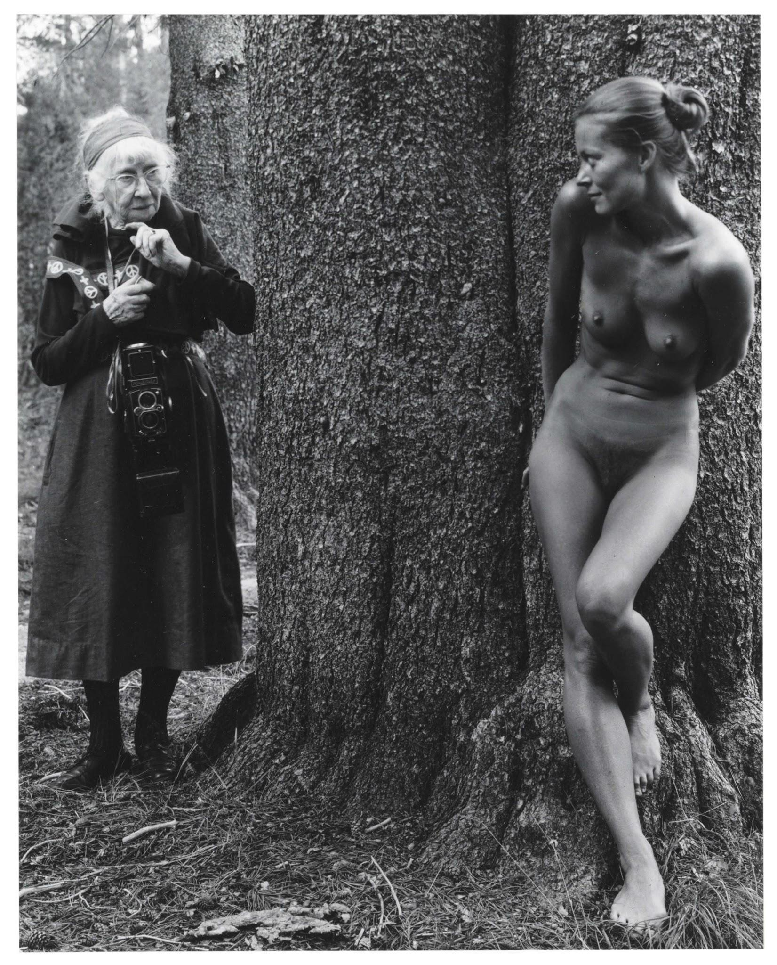
ABOUT THE ARTISTS AND PROJECTS:
Dodie Bellamy and Kevin Killian will use di Rosa’s permanent collection to explore images of exposure and surveillance and how they impact subjectivity and personhood, presenting an exhibition of works for Be Not Still that not only reflect, but challenge such standardization. Dodie Bellamy is an accomplished novelist, poet, and essayist, who specializes, in her own words, in “genre-bending work that focuses on feminism, sexuality, cultural artifacts both high and low, and all things queer.” Along with her husband Kevin Killian, Bellamy has been an active member of San Francisco’s literary avant-garde for the past four decades, and is one of the original practitioners of New Narrative. From 1995 to 2000, Bellamy was the director of Small Press Traffic Literary Arts Center, and from 1999 to 2004, wrote book reviews for the San Francisco Chronicle. Bellamy has also collaborated with various artists, including Raymond Pettibon and Lutz Bacher, and has written text for exhibitions at di Rosa, San Francisco Museum of Modern Art, the Contemporary Jewish Museum, NYU’s Fales Library and Special Collections, and galleries. Kevin Killian is a poet, novelist, playwright, art critic, and scholar who lives and works in San Francisco. He earned a BA from Fordham University and an MA at SUNY-Stony Brook. Killian’s poetry collections include Argento Series (2001), Action Kylie (2008), and Tweaky Village (2014), which Macgregor Card chose for a Wonder Prize, and Killian’s poems have been anthologized in Best American Poetry (1988) and Discontents: New Queer Writers (1992). He is also the author of various novels, short-story collections, plays, and a memoir. In addition, Killian has contributed significantly to scholarship on the life and work of American poet Jack Spicer. Bellamy and Killian just released their most recent book Writers Who Love Too Much: New Narrative Writing 1977-1997, published by Nightboat Books.
Ala Ebtekar plans to focus on citizenship and our shared humanity beyond common perceptions of time and space through a large-scale installation for Be Not Still. Ebtekar was born in Berkeley in 1978 to Iranian parents. From an early age, he acquired a deep cosmic sense of identity and developed a sensitivity towards in-between-ness, which led him to explore the spaces of/between the two cultures, both shared and separated. Such experiences evolved into a dynamic practice that disquiets dominant notions of identity and complicates cultural difference. Ebtekar received his BFA from San Francisco Art Institute and his MFA from Stanford University. He has been teaching at Stanford University since 2009 in the Department of Art & Art History and Institute for Diversity in the Arts at Stanford.
Rigo 23’s installation for Be Not Still will explore the relationship between contemporary United States political and economic leadership, and a long term view of life on Earth. His project relates earth to the spiritual realm, as indigenous peoples do, and probes how American exceptionalism impacts the way we understand the physical world we inhabit. Born on Madeira Island, Portugal in 1966, Rigo 23 has exhibited his work internationally for over 20 years, installing murals, paintings, sculptures, and tile work as public interventions where viewers are encouraged to examine their relationship to their communities. Rigo received his MFA from Stanford University and his BFA from San Francisco Art Institute, where he is currently an adjunct faculty member.

Allison Smith’s sculptural installation for Be Not Still will explore the rise of white nationalism, historical reenactment, and survivalist material culture, building on recent projects such as Common Goods at the Cambridge Arts Council/Carpenter Center for the Visual Arts at Harvard University and Models for a System at the Contemporary Jewish Museum in San Francisco. Smith is an artist and academic who has exhibited her work nationally and internationally since 1995. She has produced solo exhibitions, installations, performances, and artist-led participatory projects for venues such as SFMOMA, Public Art Fund, The Aldrich Contemporary Art Museum, The Arts Club of Chicago, and Signal Center for Contemporary Art, among many others. She was, until recently, Associate Professor and Chair of the Sculpture Program at California College of the Arts and is now Associate Professor of Art in the area of Sculpture, Installation and Site-Work at the Carnegie Mellon University School of Art in Pittsburgh, Pennsylvania.
This exhibition is organized by Amy Owen, Curator, and Kara Q. Smith, Assistant Curator with Andrea Saenz Williams, Director of Education and Civic Engagement

ABOUT DI ROSA: di Rosa is a catalyst for transformative experiences with contemporary art of Northern California. A nonprofit contemporary art center, di Rosa presents dynamic exhibitions and educational programs for all ages and houses the foremost collection of contemporary Bay Area art in the world. A wide range of styles, media, and subject matter provide an overview of the creative energy and freedom to experiment that characterize this region of California. di Rosa features three galleries, a sculpture park, a 35-acre lake, and a wildlife preserve, all located on 217 scenic acres in Napa Valley’s famed Carneros region. For more information, visit dirosaart.org.

IMAGE CREDITS: From top to bottom, left to right

- Ala Ebtekar, Zenith (IV), 2015. Courtesy of the artist.
- Rigo 23, Installation view of Teko Mbarate : Struggle for Life and Sapukay : Cry for Help at Museum of Contemporary Art in San Diego, 2008. Courtesy of the artist and Anglim Gilbert Gallery.
- Judy Dater, Imogen and Twinka, Yosemite, 1974. di Rosa Collection, Napa.

CONTACT: For images, interview requests, and curatorial media tours, contact Danielle Smith, danielle@frameworksf.com.

**Please note that an earlier version of this press release listed Ramekon O’Arwisters as an exhibiting artist.

###

