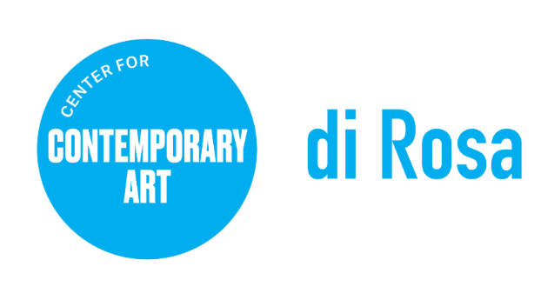

di Rosa Center for Contemporary Art
POSITION TITLE: Art & Nature Instructor
REPORTS TO: Deputy Director and Director of Education
CLASSIFICATION: Part-time hourly, non-exempt
RATE: $30/hour
Summary: Join the fun at Camp di Rosa this summer! We are hiring Art & Nature Instructors for all weeks of Camp di Rosa. Summer camp weeks are June 20 – 24, June 27 – July 1, July 11 – 15, and July 18 – 22.
Art & Nature Instructors report to the Deputy Director and Director of Education and are responsible for providing quality visual arts and nature instruction at di Rosa and its community partner sites. The position works with staff to design exciting and innovative lessons that are fun, informative, and inspire the creative potential in participants. Visual art lessons utilize media such as painting, clay and printmaking, and are generated from artworks and ideas on view at di Rosa; nature lessons involve activities such as bird watching, hiking, plant and flower identification.

About di Rosa: Protected in perpetuity under the Napa County Land Trust, the site features multiple galleries, a sculpture park, and a 35-acre lake, all located on 217 scenic acres in Napa Valley’s famed Carneros region. di Rosa originated as the vision of Rene di Rosa (1919-2010), a prolific collector whose famed vineyards enabled his development of a world-class art collection. Together with his wife Veronica di Rosa (1934–1991), he used the sale of his vineyards to build an “art park” for the greater public. The organization was incorporated as a nonprofit public trust in 2000.
Today di Rosa presents contemporary exhibitions by Bay Area-based artists and an array of educational programs for all ages, in addition to maintaining a permanent collection of notable works by artists with ties to the Bay Area from the mid-twentieth century to the early 2000’s. For more information, visit dirosaart.org.
RESPONSIBILITIES
General
- With the Art & Nature Assistant, supervise and manage a camp group of up to 12 children.
- Ensure camper safety during all activities; immediately communicate any safety to camp management.
- Obtain a CPR/First Aid certification.
- Supervise Art & Nature Assistant.
- Attend all training sessions and meetings.

Visual Arts & Nature Instruction
- Lead the set up and break down of your group’s art and activity supplies, including cleaning and organizing supplies.
- Design art lessons and nature activities as requested, submitting lesson ideas and plans on time.

SKILLS & QUALIFICATIONS
- Experience providing art instruction to groups of children ages six to fourteen.
- Knowledge of various art mediums and their applications and uses. Experience designing lessons.
- Interest in nature, hiking, and nature-related activities.
- Excellent group management and communication skills, high energy and positive attitude.
- Ability to work well independently with a track record for resourcefulness and problem solving.

To Apply, Please Provide the Following:
- Resume with education, employment history, and contact information for 2 references.
- Application materials should be emailed, in PDF format, to andrea.saenz@dirosaart.org with
“Application: Art & Nature Instructor” in the subject line.

Working Conditions: Applicants must be comfortable with and enjoy nature. Must possess a car and valid driver’s license and be willing to work weekends and occasional evenings. Physical Demands: The Visitor Services Representative position requires an ability to stand, walk, move and remain active consistently and for lengthy periods. Ability to lift 50 pounds. Ability to perform routine bending, stooping, twisting, and reaching. The physical demands described here are representative of those that must be met by an employee to successfully perform the essential functions of this job.

Please note: di Rosa Center for Contemporary Art is an Equal Opportunity Employer. All qualified applicants will receive consideration for employment without regard to race, color, ancestry, religion, sex, gender or gender identity, national origin, disability, age, citizenship status, marital status, Vietnam era or special disabled veteran's status, sexual orientation or other bases protected by law. di Rosa makes reasonable accommodations for qualified applicants and employees with disabilities as defined by and in compliance with California law.

