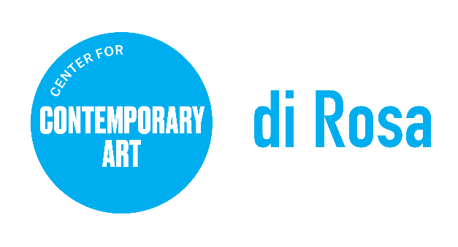

POSITION TITLE: Communications & Media Manager
REPORTS TO: Executive Director
CLASSIFICATION: 32 Hours a week
Summary:

The Communications and Media Manager will build and maintain a profile of di Rosa Center for Contemporary Art through strategic media placements and communication with various internal and external stakeholders. This includes activating an overaching brand strategy that is viable across all institutional platforms and effective in social media, marketing and public relations.

About di Rosa: di Rosa Center for Contemporary Art presents contemporary exhibitions and educational programs for all ages and maintains a permanent collection of notable works by artists living or working in the San Francisco Bay Area from the mid-twentieth century to the present day. A wide range of styles, media, and subject matter provides an overview of the creative energy and freedom to experiment that characterize this region of California. Protected in perpetuity under the Napa County Land Trust, di Rosa features multiple galleries, a sculpture park, and a 35-acre lake, all located on 217 scenic acres in Napa Valley’s famed Carneros region. For more information, visit dirosaart.org.

KEY RESPONSIBILITIES

- Drives a comprehensive public relations program including research, planning, execution and measurement.
- Coordinates and distributes messaging and collateral.
- Collaborates with internal teams to organize amplification of key messages across all platforms.
- Manages the organization’s active website.
- Is engaged and attuned to the consumer media landscape, actively seeking new contacts and making connections with new media platforms.
- Coordinates production and dissemination of exhibition and public programs announcements as well as organization collateral and visitor information.
- Seeks out and responds to information requests for inclusion in public directories and listings.
- Maintains accurate and up to date media mailing lists.
- Perform other duties as may be assigned by Supervisor.

SKILLS & QUALIFICATIONS

- Intellectually curious, creative, strategic and self-motivated.
- Adept at communication across all social media platforms.
- Ability to multi task and prioritize effectively.
- Skilled with Adobe Suite, InDesign, and Word Press.
- Dependable, punctual, courteous, discrete.
- Impeccable copywriting and editing skills.
- Proven time management skills.
- Interest or background in the arts.

To Apply, Please Provide the Following:

- Cover letter addressing your interest in the position.
- Resume with education, employment history, and contact information for 3 references.
- Application materials should be emailed in PDF format to: admin@dirosaart.org

Please note: di Rosa Center for Contemporary Art is an Equal Opportunity Employer. All qualified applicants will receive consideration for employment without regard to race, color, ancestry, religion, sex, gender or gender identity, national origin, disability, age, citizenship status, marital status, Vietnam era or special disabled veteran's status, sexual orientation or other bases protected by law. di Rosa makes reasonable accommodations for qualified applicants and employees with disabilities as defined by and in compliance with California law.

August 31, 2022

