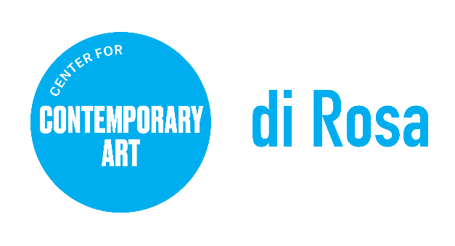

di Rosa Center for Contemporary Art

POSITION TITLE: Gallery Attendant
REPORTS TO: Site & Facilities Manager
CLASSIFICATION: Part Time (up to 20 hours per week)
COMPENSATION: $20 per hour

Summary: di Rosa Center for Contemporary Art seeks a part time Gallery Attendant to ensure the protection and safety of our galleries and campus, providing a safe and secure environment for the center’s exhibitions, facilities, visitors and staff while delivering excellent customer service.

About di Rosa: di Rosa Center for Contemporary Art presents contemporary exhibitions and educational programs for all ages and maintains a permanent collection of notable works by artists living or working in the San Francisco Bay Area from the mid-twentieth century to the present day. A wide range of styles, media, and subject matter provides an overview of the creative energy and freedom to experiment that characterize this region of California. Protected in perpetuity under the Napa County Land Trust, di Rosa features multiple galleries, a sculpture park, and a 35-acre lake, all located on 217 scenic acres in Napa Valley’s famed Carneros region. For more information, visit dirosaart.org.

KEY RESPONSIBILITIES
- Establish and maintain communications with Facilities and Visitor Services at the start and end of shift and throughout the day (radios and phones)
- Open gates/close gates at the beginning/end of the day
- Walk and maintain regular visual contact with all gallery areas accessible to the public, looking for hazards or issues that need immediate attention; notify staff in charge/manager on duty
- Walk through all galleries at least once per hour minimum
- Continually monitor all parking lots for suspicious activities, and report as needed
- Answer visitor questions in a professional manner, and direct guests as needed
- Maintain regular communication with shuttle operator (one hour minimum frequency)
- Notify 911 immediately of any emergencies on the premises, and notify supervisor and/manager on duty immediately following
- Perform other duties as may be assigned by supervisor
- QUALIFICATIONS
- Ability to display good judgment and respond effectively in dealing with staff and visitors regarding the safety and security of the facilities
- Ability to: consistently present a neat, professional, and courteous appearance to visitors and staff; exercise tact and diplomacy at all times and remain calm under pressure; demonstrate flexibility, strong work ethic and integrity and professionalism in performance of duties
- Punctual, dependable, and flexible
- Available to work variable schedules including evenings, weekends, and holidays
- One year of experience in security preferred ideally with a museum or educational environment

Working Conditions: di Rosa is located on 217 acres in the Carneros region of Napa Valley. Applicants must be comfortable with and enjoy nature, including native waterfowl. Position requires standing for long periods of time, climbing stairs, and ability to lift/move up to 50 lbs. Must possess a car and valid driver’s license and be willing to work occasional nights and weekends.

To Apply, Please Provide the Following:
- Resume with education, employment history, and contact information for 3 references
Application materials should be emailed in PDF format to: facilities@dirosaart.org. No phone calls please. To learn more about di Rosa, visit www.dirosaart.org

Please note: di Rosa Center for Contemporary Art is an Equal Opportunity Employer. All qualified applicants will receive consideration for employment without regard to race, color, ancestry, religion, sex, gender or gender identity, national origin, disability, age, citizenship status, marital status, Vietnam era or special disabled veteran's status, sexual orientation or other bases protected by law. di Rosa makes reasonable accommodations for qualified applicants and employees with disabilities as defined by and in compliance with California law.

