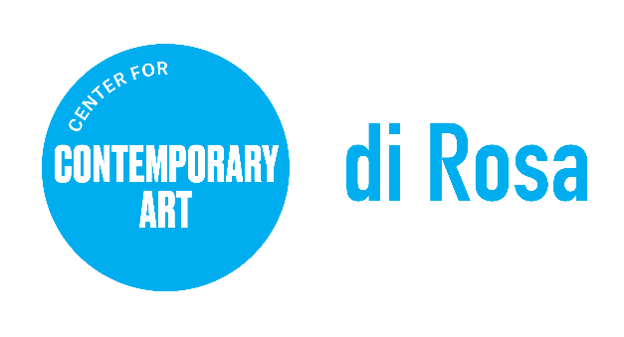

POSITION ANNOUNCEMENT

POSITION TITLE: Site Maintenance Assistant
REPORTS TO: Site & Facilities Manager
CLASSIFICATION: Part Time, non-exempt
COMPENSATION: $18-24 per hour

Position Details: di Rosa Center for Contemporary Art seeks a part time Site Maintenance Assistant to provide support for the maintenance, care and repairs of di Rosa’s building and site. The Site Maintenance Assistant works under the direction of the Site and Facilities Manager as part of the Site and Facilities Team.

About di Rosa: di Rosa Center for Contemporary Art presents contemporary exhibitions and educational programs for all ages and maintains a permanent collection of notable works by artists living or working in the San Francisco Bay Area from the mid-twentieth century to the present day. A wide range of styles, media, and subject matter provides an overview of the creative energy and freedom to experiment that characterize this region of California. Protected in perpetuity under the Napa County Land Trust, di Rosa features multiple galleries, a sculpture park, and a 35-acre lake, all located on 217 scenic acres in Napa Valley’s famed Carneros region

KEY RESPONSIBILITIES
- Assists with the maintenance and care of buildings and equipment, including hands-on repairs and maintenance, cleaning and monitoring of buildings and public areas, and scheduled vehicle and equipment maintenance
- Maintenance and daily preparation of site for guess
- Communicate with supervisor to determine maintenance needs, identify issues or concerns, and suggest solutions in a collaborative work environment
- Assist with preparation of building and/or site for exhibitions, public programs, and other events and provide support during events as needed
- Perform other duties as may be assigned by supervisor

MINIMUM QUALIFICATIONS
Work Experience
- Minimum two years of hands-on experience in care for and maintenance of buildings and grounds including repairs and minor upgrades
- Ability to: consistently present a neat, professional, and courteous appearance to visitors and staff; exercise tact and diplomacy always and remain calm under pressure; demonstrate flexibility, strong work ethic and integrity and professionalism in performance of duties
- Punctual, dependable, and flexible
Education and Training
- Interest in and awareness of environmental issues is important. Background and/or interest in organic methods a plus
Skills and Abilities
- Basic English skills required (reading, writing, comprehension and speaking). Good communication skills are important, as is the ability to follow written and verbal instructions.
- Ability to perform minor upgrades and repairs to buildings, janitorial duties also include but not limited to; cleaning restrooms, floor maintenance (vacuuming, mopping and sanitizing), cleaning windows, cleaning offices, interior and exterior walls of buildings, hosing off entrances and patios, using a power washer and removing trash and recycling daily from offices and kitchen
- Basic computer skills are desirable. Applicant is resourceful and a self-starter, who enjoys working with others in an informal, fast-paced environment.

Working Conditions and Environment: di Rosa is located on 217 acres in the Carneros region of Napa Valley. Applicants must be comfortable with and enjoy nature, including native waterfowl. Position requires standing for long periods of time, climbing stairs, and ability to lift/move up to 80 lbs. Must possess a car and valid driver’s license and a good driving record.

To Apply, Please Provide the Following:
- Resume with education, employment history, and contact information for 3 references
Application materials should be emailed in PDF format to: admin@dirosaart.org. No phone calls please. To learn more about di Rosa, visit www.dirosaart.org

Please note: di Rosa Center for Contemporary Art is an Equal Opportunity Employer. All qualified applicants will receive consideration for employment without regard to race, color, ancestry, religion, sex, gender or gender identity, national origin, disability, age, citizenship status, marital status, Vietnam era or special disabled veteran's status, sexual orientation or other bases protected by law. di Rosa makes reasonable accommodations for qualified applicants and employees with disabilities as defined by and in compliance with California law.

