FOR IMMEDIATE RELEASE:
Hi-res Images and Captions

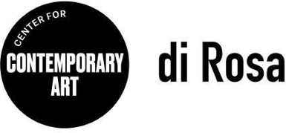
di Rosa Media Contact: Allison Coats
allison@coatspr.com or (707) 363-6508

di Rosa Invites Submissions for Local Artist Showcase
NAPA, CA (September 8, 2022) – Want to see your artwork in di Rosa’s galleries?
di Rosa Center for Contemporary Art invites submissions for True North, a juried exhibition celebrating art from the North Bay. Visual artists living or working in Napa, Sonoma, Marin or Solano counties are invited to submit works by the deadline of October 3, 2022, at www.dirosaart.org/true-north.

“The North Bay is often seen as peripheral to the Bay Area art world – but we are committed to de-centering this view by engaging and supporting artists from our local communities,” states Executive Director Kate Eilertsen. “The North Bay is facing critical issues – from a skyrocketing cost of living to the precarity of our natural environment – and our hometown artists have much to say.”

True North is conceived as a survey of local talent that will generate artistic activity and spark dialogue among diverse practitioners of the arts within the region. The exhibition will open to the public December 16, 2022-January 15, 2023.

Submissions will be evaluated by a distinguished panel of jurors comprising sculptor and performance artist Ashwini Bhat, painter Chester Arnold and art advisor Chandra Cerrito. Selected artists will be fêted at a members’ opening reception held December 15, 2022.
ABOUT DI ROSA CENTER FOR CONTEMPORARY ART
di Rosa Center for Contemporary Art is located at 5200 Sonoma Highway, Napa. The campus is open to the public Friday and Sunday from 11 AM to 4 PM, and by appointment Tuesday through Thursday. For more information visit www.dirosaart.org.
###

