FOR IMMEDIATE RELEASE:
Photos below and available here.

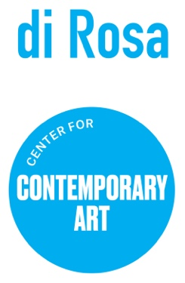

Our Bodies, Ourselves Highlights Female Photographers in di Rosa Collection
Exhibition celebrates the female gaze in contemporary photography
April 14 thru July 30
Napa, CA (April 10, 2023) – di Rosa Center for Contemporary Art announces its newest exhibition Our Bodies, Ourselves (April 14-July 30, 2023). The exhibition showcases female photographers in the di Rosa collection.
Since the 1970s, photographers have reclaimed the female gaze, picturing women’s’ bodies in ways not intended for male consumption. The works ask us to reconsider the camera lens as a tool of male power, raising questions about what kinds of bodies deserve depiction while centering issues of health and sexuality, body positivity and gender-based violence.
“As we live through the erosion of women’s rights on both legal and cultural fronts, it is more important than ever to celebrate the female voices in our collection,” states Executive Director Kate Eilertsen. “We are committed to using our collection to elevate marginalized perspectives.”
Artists highlighted in the exhibition include a who’s who of feminist photographers from the Bay Area including: Ruth Bernhard, Judy Dater, Dana Bonick, Nina Glaser and Teresa Chen. Concurrently on view this summer Natural Discourse @ di Rosa highlights the works of contemporary female photographers turning their lenses on the natural world.
ABOUT DI ROSA CENTER FOR CONTEMPORARY ART
di Rosa is an art park and nature preserve on 217 acres in Carneros. Located at 5200 Sonoma Highway, di Rosa sits smack dab between Napa and Sonoma. The property includes two large art galleries, a beautiful lake, abundant birding, walking trails with vineyard views, outdoor sculptures, and picnic grounds.
Specializing in the art of Northern California, di Rosa presents contemporary exhibitions by Bay Area-based artists in addition to maintaining a permanent collection of notable works by artists with ties to the Bay Area from the mid-twentieth century to the early 2000’s. di Rosa offers an array of public programs and events for all ages to inspire creativity and curiosity.
di Rosa is open to the public Friday through Sunday from 11 am to 4 pm, and by appointment Tuesday through Thursday. Visitors are encouraged to bring picnics. Outside food and drink is welcome. Children and educators are always free at di Rosa. For more information visit www.dirosaart.org.
# # #
Media contact: Allison Coats allison@coatspr.com or (707) 363-6508
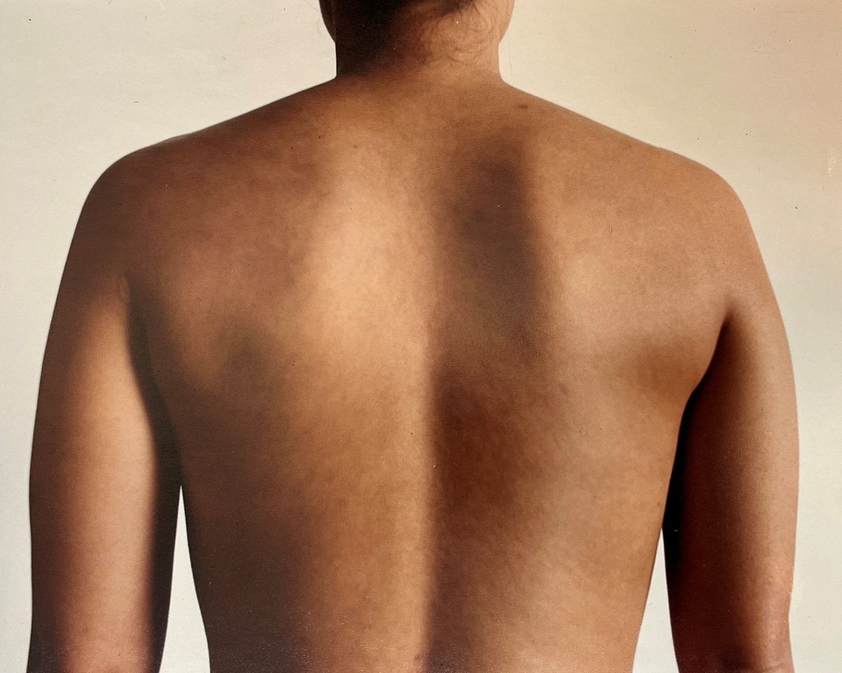
Teresa Chen
Self-Portrait with Bruises
1996
Chromogenic print

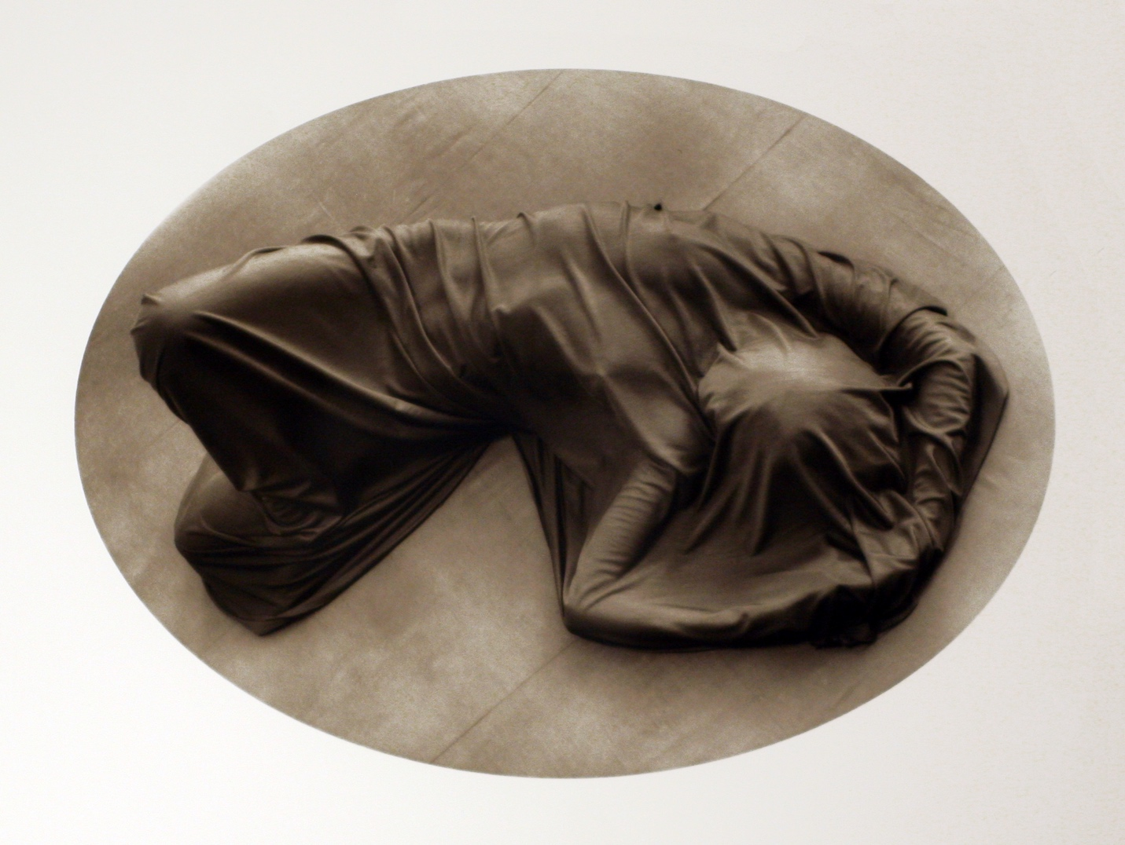
Ruth Bernhard
Enigma
1976
Gelatin silver print

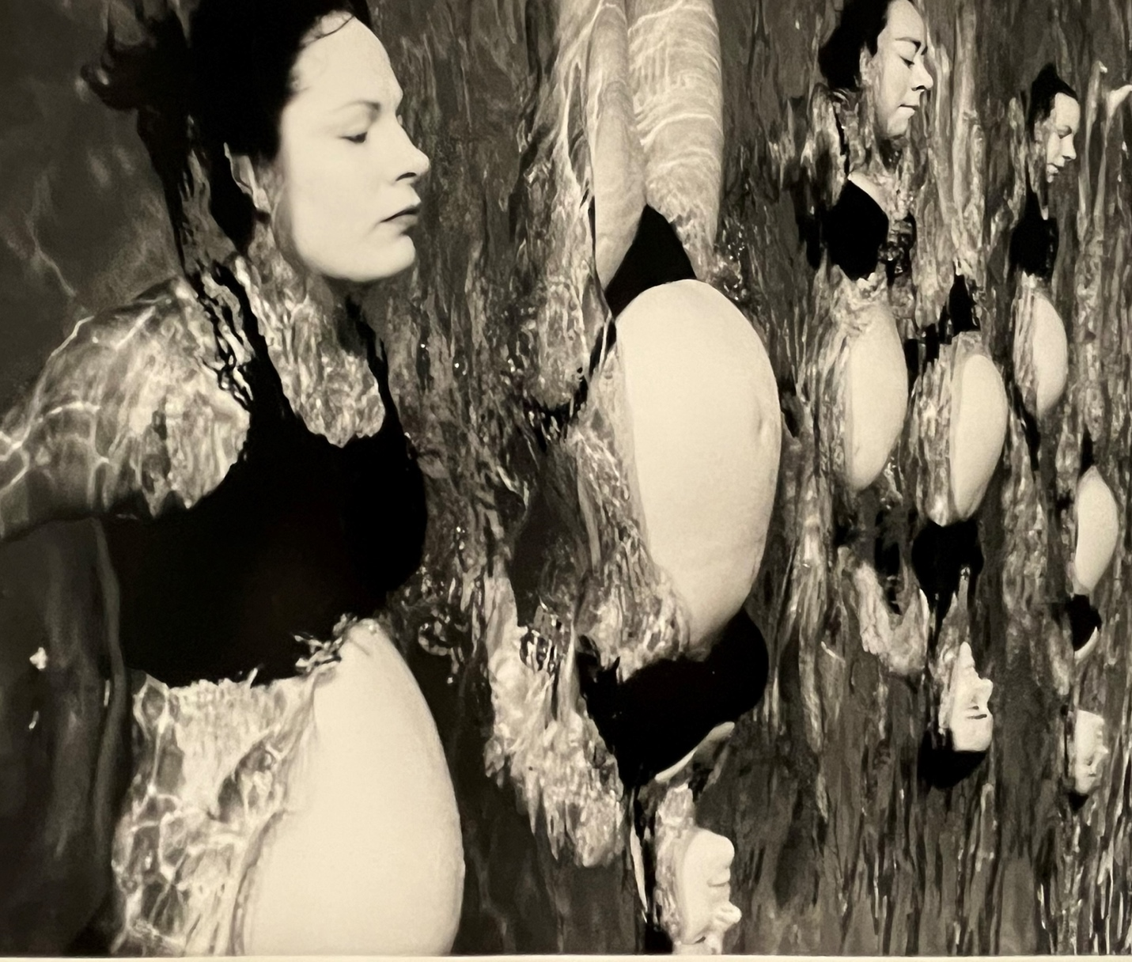
Christine Luksza-Paravicini
Lily Pads
1998
Gelatin silver print

