FOR IMMEDIATE RELEASE:
Photos below and available here.

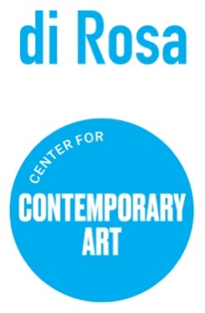

Figure Telling: Contemporary Bay Area Figuration
Opening Reception Saturday June 3 at 5:30pm
Napa, CA (May 11, 2023) – Figure Telling, on display at di Rosa Center for Contemporary Art from June 3-September 17, 2023, highlights a multigenerational group of Bay Area artists using the human figure to produce works grounded in narrative, storytelling, and personal memory. The exhibition highlights six artists – Sydney Cain, Craig Calderwood, John Goodman, Afsoon Razavi, Josephine Taylor and Heather Wilcoxon –using the human form to tell individual, family, and community stories.
“These artists use visual storytelling to convey their unique identities, histories, concerns, and compassions,” states curator Kate Eilertsen. “In a world that is so often complex, they use human figures to tell stories – sometimes ugly and sometimes beautiful, always honest.”
The public is invited to attend an Opening Reception on Saturday, June 3, 5:30-7pm. This event is free for members and $10 for general public. Guests will mingle with artists and enjoy an intimate performance by UPside Dance Company. Tickets are available for purchase at www.dirosaart.org.
At the opening, and throughout the run of the show, visitors will participate in dynamic gallery activations. All ages are invited to enjoy a pop-in figure drawing area in the gallery. Visitors are also encouraged to compose personal stories inspired by artworks in the show and add them to the community Figure Telling wall. A Figure Telling panel is in planning stages for late summer.
ABOUT THE ARTISTS
Sydney Cain is a visual artist born and raised in San Francisco, CA. Through large scale and intimate works, Cain honors those who have passed on and provides them with sacred sites to be reborn and reimagined. Current works with printmaking, powdered metals and sculpture mine personal archives, their family’s genealogy, and the intersections of urban renewal and displacement on the psychic, spiritual, emotion and physical wellbeing of marginalized communities. Cain, currently in graduate school at Yale University, is represented by Rena Bransten Gallery, and has exhibited at SOMArts, and the Oakland Museum of California, among others.
Craig Calderwood, a self-taught artist, uses low-end materials like found fabrics, polymer clay and fiber tip pens to create intricate and decorative works rendered through a personal vernacular of symbols and patterns, arranged into constellations that tell stories both personal and fantasized. Calderwood's work has been exhibited at the Oakland Museum of California, Mills College Art Museum and Museum of Craft and Design, among others.
John Goodman, a self-taught artist who draws inspiration from the Bay Area Figurative painters, came to painting after a long and successful career as a playwright. His storytelling skill is central to his being and career. His understated minimalism, signature impasto brushwork and reductive use of color speak of isolation and eternity. Goodman lives and works in San Francisco, CA, and is represented by the Andra Norris Gallery, Burlingame.
Afsoon Razavi is an Iranian-American artist and designer living and working in Napa, California. With her charcoal drawings of free-flowing hair, Razavi tells the story of Iranian women’s protests and self-determination as their government prohibits them from showing their hair in public.
Josephine Taylor's mysterious drawings leave us searching for the sources of her history. Using delicate colors with meticulous details, Taylor explores the traumas and joys of contemporary experience. Taylor is a 2017 Fleishhacker Foundation Eureka Fellow and a 2004 recipient of the SFMOMA SECA award, among other accolades. She is represented by Catharine Clark Gallery in San Francisco and opens a solo exhibition at the gallery in September 2023.
Heather Wilcoxon’ figures explore issues like abortion and immigration. Each piece has a story to tell – however she allows space for each viewer to make up their own narrative. Having studied at the San Francisco Art Institute, Wilcoxon lives and works in Sausalito, CA. She has received fellowships including two from the Pollack/Krasner Foundation, and recently received the Distinguished Women in the Arts Award from the Fresno Art Museum.
ABOUT DI ROSA CENTER FOR CONTEMPORARY ART
di Rosa is an art park and nature preserve on 217 acres in Carneros. Located at 5200 Sonoma Highway, di Rosa sits smack dab between Napa and Sonoma. The property includes two large art galleries, a beautiful lake, abundant birding, walking trails with vineyard views, outdoor sculptures, and picnic grounds.
Specializing in the art of Northern California, di Rosa presents contemporary exhibitions by Bay Area-based artists in addition to maintaining a permanent collection of notable works by artists with ties to the Bay Area from the mid-twentieth century to the early 2000’s. di Rosa offers an array of public programs and events for all ages to inspire creativity and curiosity.
di Rosa is open to the public Friday through Sunday from 11 am to 4 pm, and by appointment Tuesday through Thursday. Visitors are encouraged to bring picnics. Outside food and drink is welcome. Children and educators are always free at di Rosa. For more information visit www.dirosaart.org.
# # #
Media contact: Allison Coats allison@coatspr.com or (707) 363-6508
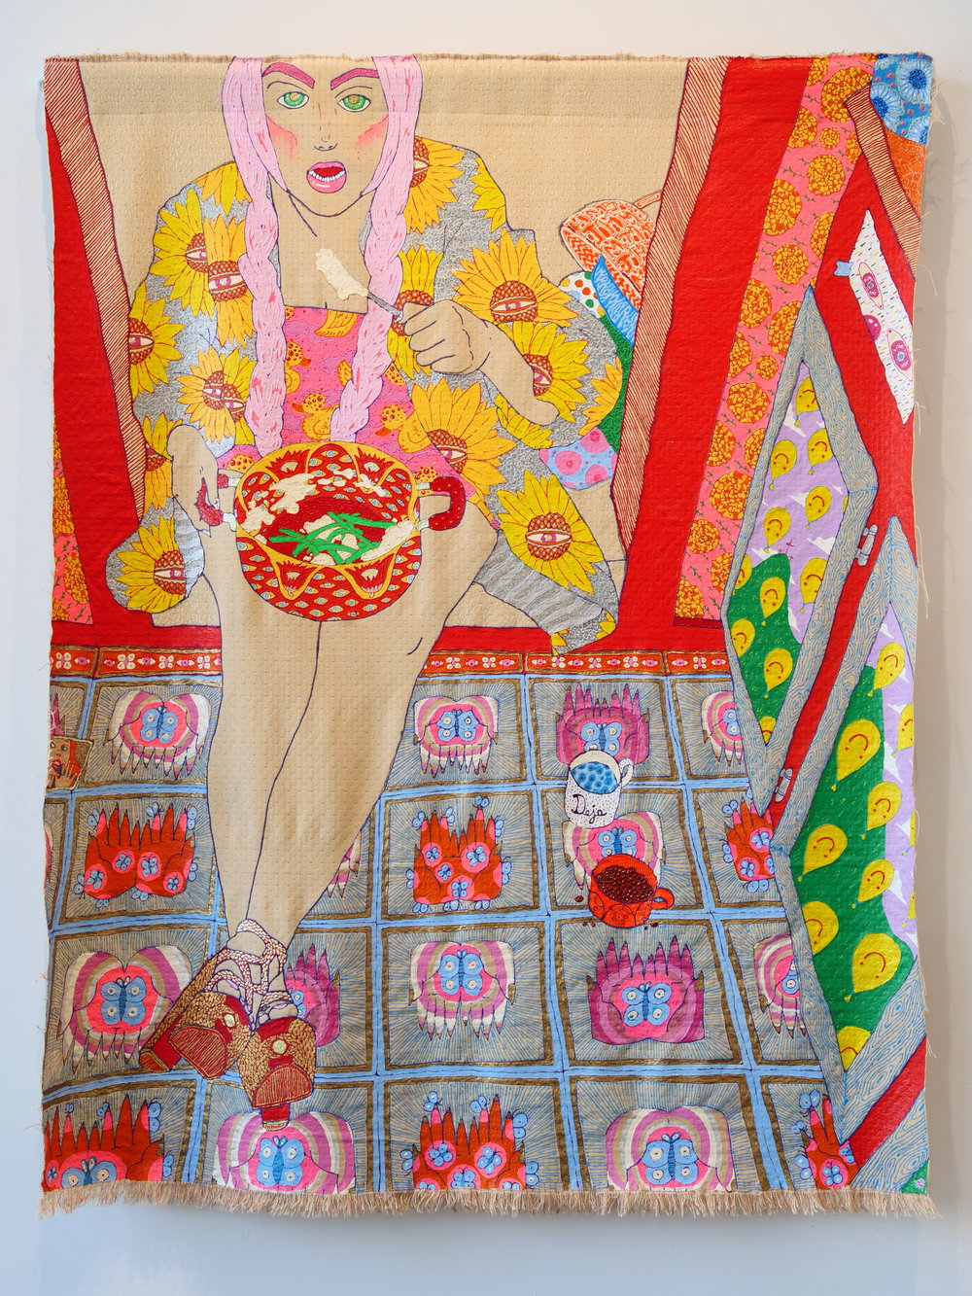

Craig Calderwood
How's Your Jesus Christ Been Hanging?, 2018
Dimensional paint, thread on upholstery fabric
Image courtesy the Artist and George Adams Gallery, New York

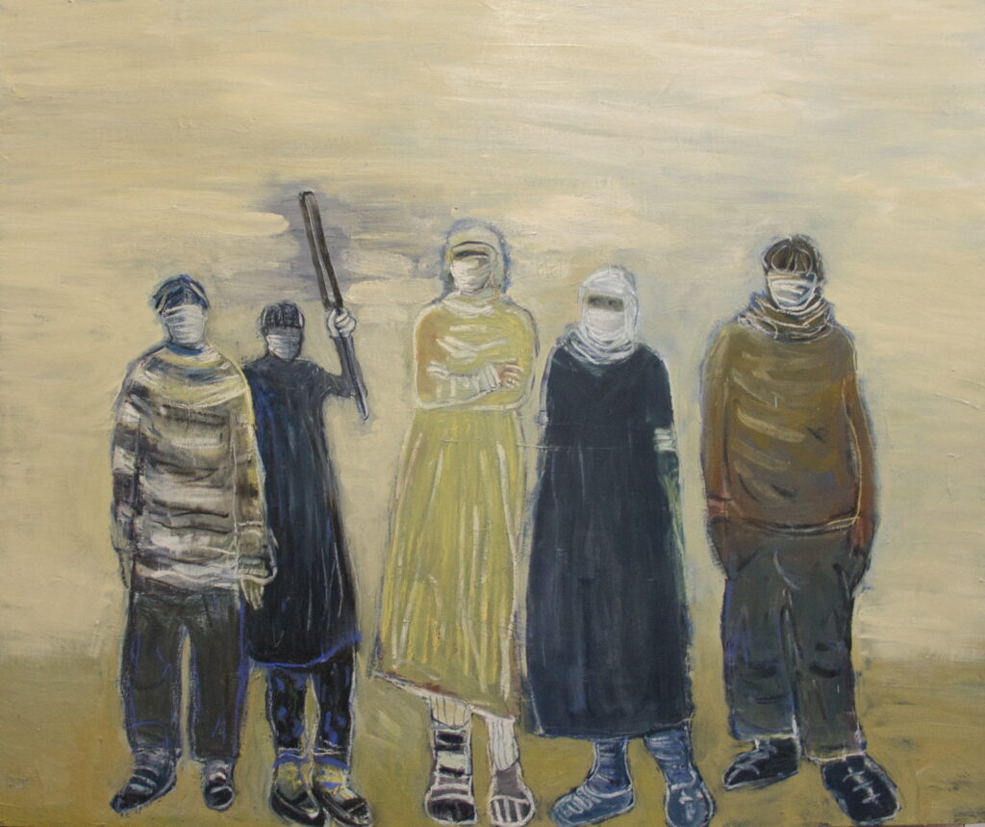
Heather Wilcoxon
Family, 2023
Oil on canvas
Courtesy of the Artist

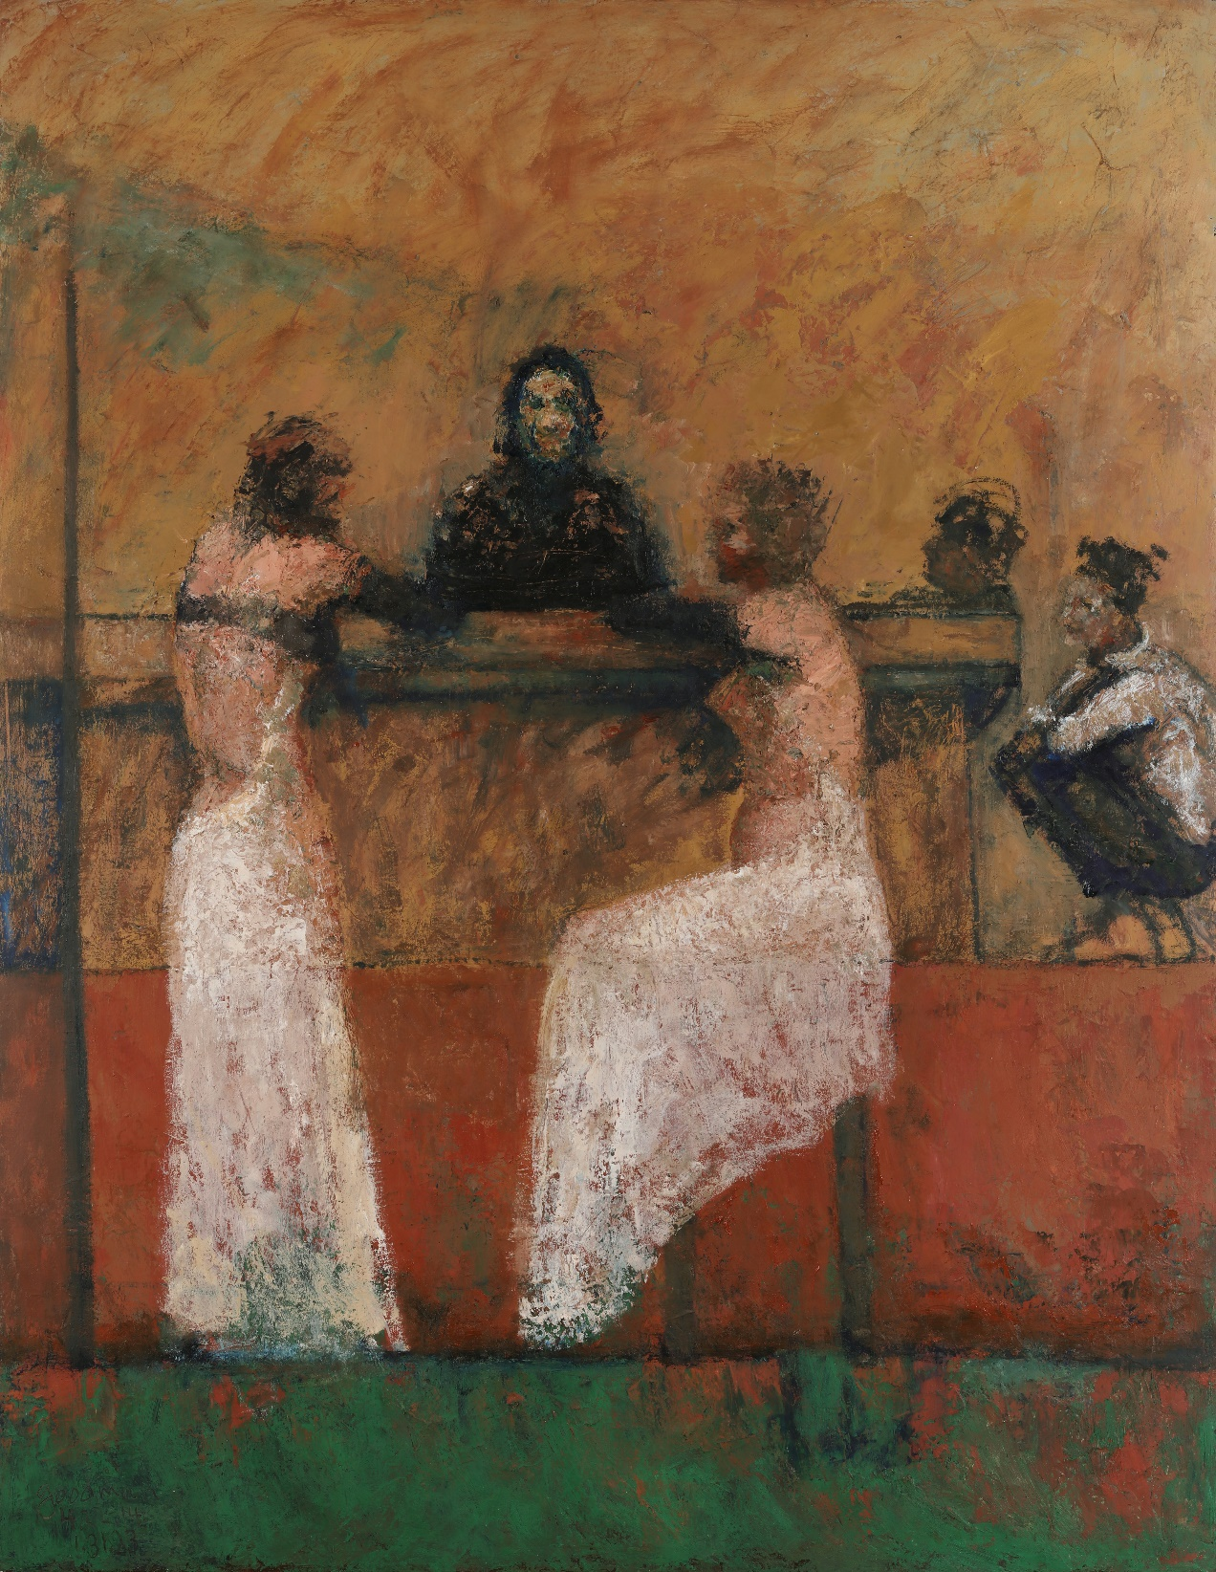

John Goodman
Illustration for Untold Stories #18, 2023
Oil on canvas
Courtesy of the Artist

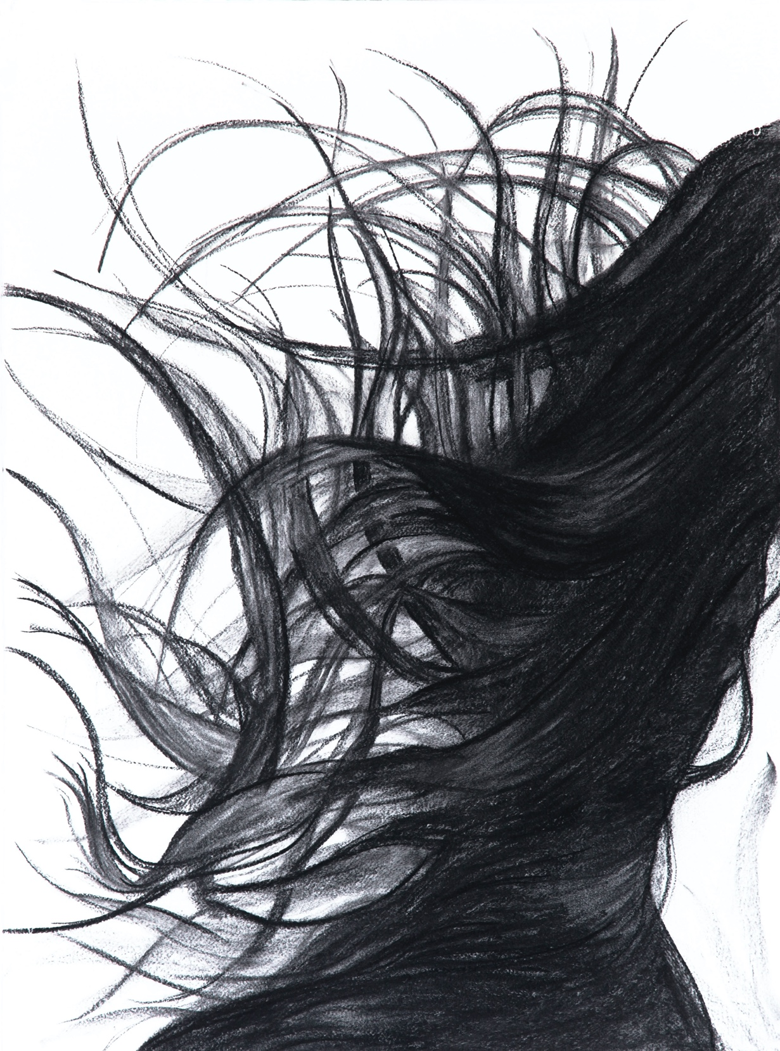

Afsoon Razavi
casting off, 2022
Charcoal on paper
Courtesy of the Artist

