FOR IMMEDIATE RELEASE:
Images in link

Listen Louder: Ana Teresa Fernández opens on Saturday, October 7 at di Rosa

Contemporary artist explores intersection of migration and climate change

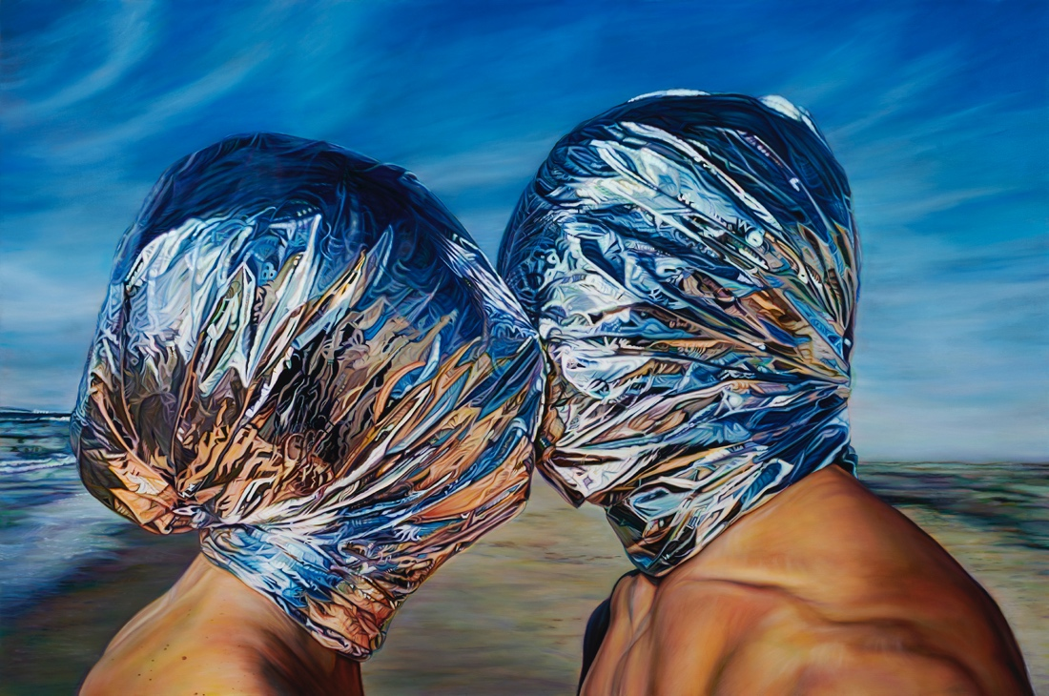

Ana Teresa Fernández, The Space Between Us, 2022, artwork courtesy of the Alvarez Collection. Image courtesy of the artist.
Napa, Ca. (September 19, 2023)—di Rosa Center for Contemporary Art is pleased to present Listen Louder: Ana Teresa Fernández (October 7, 2023-January 21, 2024). In her largest career survey to date, San Francisco-based multidisciplinary artist Fernández shows paintings, sculptures, and films, alongside site-specific installations and performances exploring the intersection of migration and climate change. An opening reception for the public will be held on Saturday, October 7 from 5:30 to 7 p.m. Tickets $10 per person and free for di Rosa members, available at dirosaart.org.

Land-based installations – including a glittering ‘SHHH’ floating on di Rosa’s Winery Lake, and an exhortation to ‘LISTEN’ visible from Sonoma Highway – encourage us to listen louder to the earth, and each other. Inside the gallery the exhibition features paintings, sculptures, videos, and photographs from major projects including At the Edge of Distance (2022), Of Bodies and Borders (2018 – 2019), and Borrando La Frontera (Erasing the Border) (2011/2021) which foreground Fernández’s continued inquiry into narratives around the border.

Fernández’s rigorous practice emerges from site-specific interventions and embodied actions, and her work frequently meditates on how borderlands delimit movement and stasis; freedom and detention; even life and death. Through enacted narratives, she embodies the stories that divide but also bind us as human beings sharing a planet of great fragility and beauty.

“The physical border dividing the United States and Mexico,” Fernández notes, “is six inches wide, yet the perils built upon that divide stretch hundreds of miles in either direction. The hate and fury that the border evokes manifests itself in militia members with assault rifles on either side of this divide, and detention centers where families are severed indefinitely while incarcerated in ice-cold concrete rooms. We are in a moment where we insist that we hold our actions and encounters at a distance, but this is not the social distance of a pandemic; this is the distance from our hearts to our minds.”

Fernández draws on site-specific actions at the border between Tijuana and San Diego, a frequent site of intervention in the artist’s work. Wrapped in a silver mylar emergency blanket – originally developed by NASA in the 1960s – Fernández holds the blanket against a laundry line as its mirrored surface reflects the light and flutters in the wind. The blanket obscures the artist’s body, a doubled effect that suggests both the comfort of cover as well as a chilling erasure of self. Fernández writes that, “emergency blankets, while created by NASA to provide warmth and insulation for astronauts in space, now are used to isolate bodies on earth, in detention camps and ice-cold cells. This space shell is as thin as 50 micrometers and weighs less than a pound, but it bears the heavy weight of being isolated from your loved ones and the weight of no longer having your child in your arms.”

The exhibition coincides with the unveiling of Circulation, Fernández’s major new public art commission for the City of Napa. “We are honored to work with the City to highlight the work of this important artist,” states di Rosa Executive Director Kate Eilertsen. “Her work raises vital questions about links between border politics and our changing planet, questions especially relevant to Napa and Sonoma communities.”

"Circulation represents the interconnection we need to provide life and sustain the ability to grow,” Fernández explains, “the pulse of our community that intersect the lives of people who harvest the land as much as the people who enjoy the fruits. The sculpture’s lines evoke the rows of vines which host grapes from all over the world, side by side. Similarly, many hands from all walks of life, and different parts of the world, work side by side braiding this connection. Napa exists and thrives because work visas allow migrants access to come from afar and work the land. An invisible constellation has made this circulatory system possible.”

ABOUT THE ARTIST

Ana Teresa Fernández (b. 1980) is an artist of border erasure who elevates the intersectionality of place, person, and politics to create a common human vernacular. Time-based actions and social gestures are her syntax. Land, history, gender, climate, and culture are her subjects. Performance, video, photography, painting, and sculpture became her dynamic tools of grammar.

Born in Tampico, Mexico, Fernández grew up in California and made her home in San Francisco. She has created residencies and public work in Haiti, Brazil, Spain, South Africa, Cuba, Mexico and throughout the United States. Major public projects include On The Horizon, which was featured in the 2021 Lands End exhibition, organized by the FOR-SITE Foundation. In one highly visible work, she erased the border between Tijuana and San Diego by painting a portion sky blue, while wearing a tango dress and heels to create an illusion of a hole on the wall from afar.

Fernández’s work was featured as a Solo Booth at the Armory Show in 2022 as part of a special curated presentation of work by artists centered on environments and borders selected by Carla Acevedo-Yates. Her work is in the permanent collections of the Fine Arts Museums of San Francisco; the Indianapolis Museum of Art; the Blanton Museum of Art; the Denver Art Museum; the Nevada Museum of Art; and the Kadist Art Foundation, among others.

ABOUT DI ROSA CENTER FOR CONTEMPORARY ART
di Rosa is a non-profit art center and nature preserve specializing in the art of Northern California. Located on 217 acres in the Carneros region of Napa, di Rosa includes two large art galleries, a beautiful lake, abundant birding, walking trails with vineyard views, outdoor sculptures, and picnic grounds.

di Rosa presents contemporary exhibitions by Bay Area-based artists in addition to maintaining a permanent collection of notable works by artists with ties to the Bay Area from the mid-twentieth century to the early 2000’s.

di Rosa offers an array of public programs and events for all ages to inspire creativity and curiosity. di Rosa is open to the public without reservations Friday through Sunday from 11 am to 4 pm, and by appointment Tuesday through Thursday. Visitors are encouraged to bring picnics. Children and educators are always free at di Rosa. For more information visit www.dirosaart.org.

###

Media contact: Allison Coats allison@coatspr.com or (707) 363-6508

