FOR IMMEDIATE RELEASE:
Images below and available here

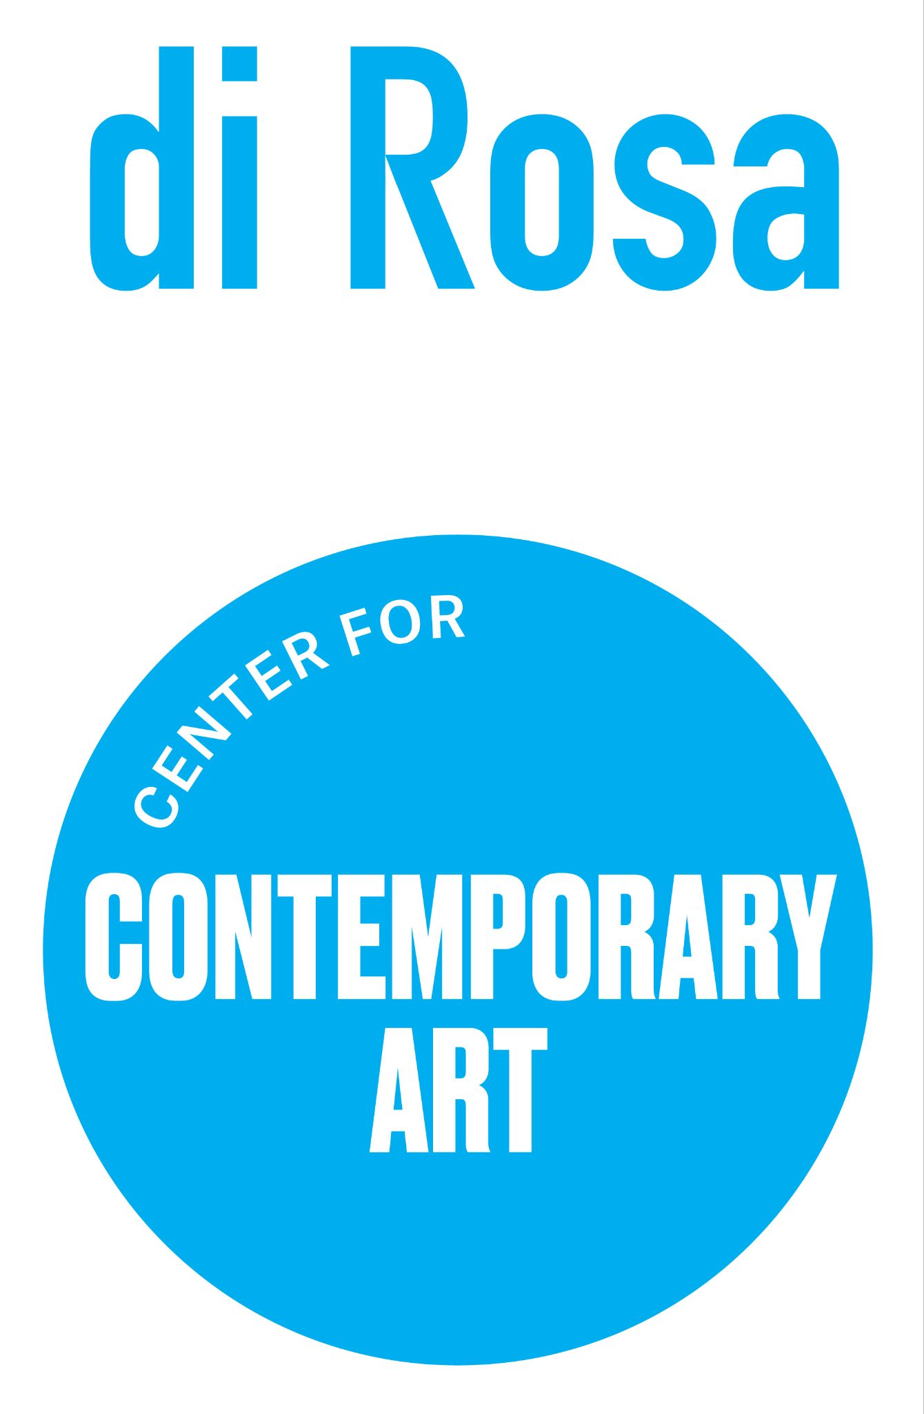

di Rosa Center for Contemporary Art Announces
WE THE PEOPLE

Video projection by Jock McDonald to illuminate di Rosa’s exterior
February 10 through April 21

McDonald, son of Veronica di Rosa and nationally-acclaimed photographer, returns to di Rosa with installation championing pluralism and inclusion

Napa, CA (Jan. 10, 2024) – di Rosa Center for Contemporary Art is pleased to present We the People, a video projection by photographer Jock McDonald displayed on the center’s exterior, overlooking Sonoma Highway. Visible nightly between the hours of 6-10pm, the installation features stirring black-and-white portraits of San Franciscans morphing and blending into one another in a timely illustration of our connection and shared humanity.

The project, born during the isolation of pandemic quarantine, “sets out to reveal our connectedness,” McDonald explains. Taking on new meaning at the dawn of an election year, the project embodies values of pluralism, diversity, equity, and inclusion. “Humans inhabiting this planet with so many others often forget all the things we have in common and share with each other,” the artist explains. "The installation challenges our tribal ‘us and them’ mentality, illuminating our commonality and community on this magnificent, round, spinning blue globe.”

The exhibition is generously supported by the KHR McNeely Family Fund.

The public is invited to a Tailgate Opening Reception on Saturday, February 10, weather permitting, from 5-7pm. Held in di Rosa’s parking lot, the reception will feature bites by Oakville Grocery Food Truck. After an address by the artist attendees will be treated to a special screening of Godzilla. Tickets are free for members and $10 for non-members and can be purchased by visiting www.dirosaart.org. This event will be rescheduled in the case of rain to Saturday, February 17.

On Saturday, April 6, McDonald will host a Portrait Photography Workshop at di Rosa from 11am-6pm. Tickets and information will be available at www.dirosaart.org.

ABOUT THE ARTIST
Jock McDonald is a fine art photographer whose work has been widely published and exhibited in museums and galleries throughout the world. Born in Vancouver, Canada, and based in the San Francisco Bay Area, McDonald is a self-taught photographer whose work has achieved acclaim for its distinctive understanding of humanity, our shared commonalities, and its qualities of connectivity and empathy. His photographs are held in numerous institutional and corporate collections including the Smithsonian Museum of American Art; the Museum of Fine Arts Houston; the Santa Barbara Museum of Art; and Fototeca de Cuba in Havana.

ABOUT DI ROSA CENTER FOR CONTEMPORARY ART
di Rosa Center for Contemporary Art presents contemporary exhibitions and educational programs for all ages and maintains a permanent collection of notable works by artists living or working in the San Francisco Bay Area from the mid-twentieth century to the present day. A wide range of styles, media and subject matter provides an overview of the creative energy and freedom to experiment that characterize this region of California. di Rosa features multiple galleries, a sculpture park and a 35 acre lake, all located on 217 scenic acres in Napa Valley’s famed Carneros region that are protected in perpetuity under the Napa County Land Trust. di Rosa Center for Contemporary Art is located at 5200 Sonoma Highway, Napa. The campus is open to the public Thursday through Sunday from 11 AM to 4 PM, and by appointment Tuesday through Wednesday. For more information visit www.dirosaart.org.

# # #

Media Contact: Allison Coats, allison@coatspr.com or (707) 363-6508
di Rosa Contact: Blake Walker, blake.walker@dirosaart.org

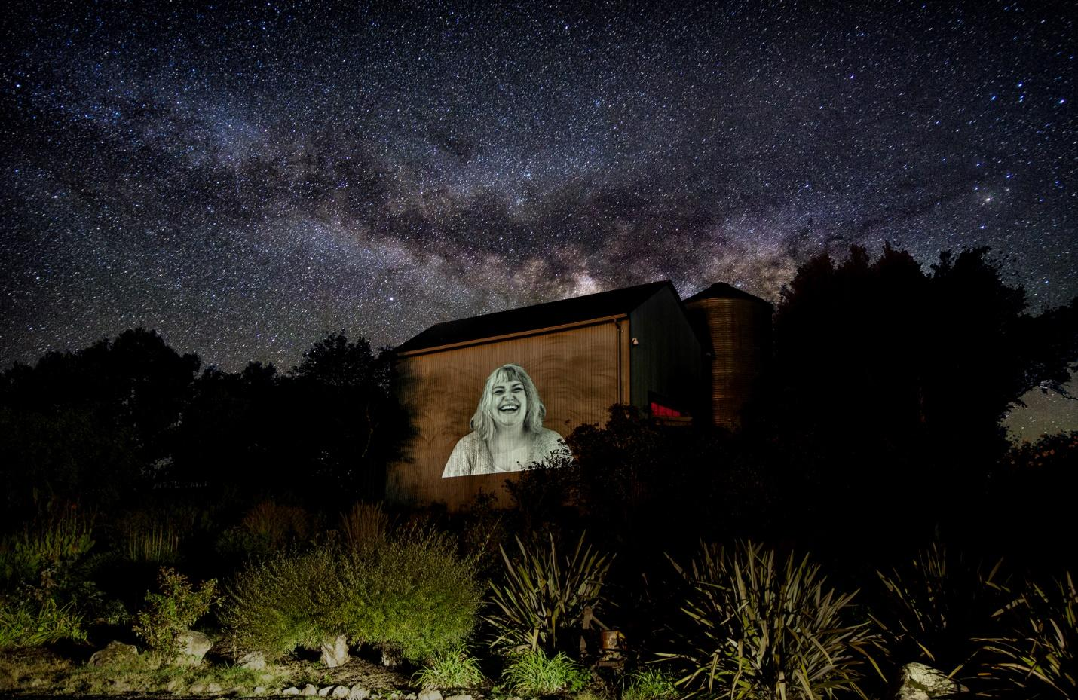

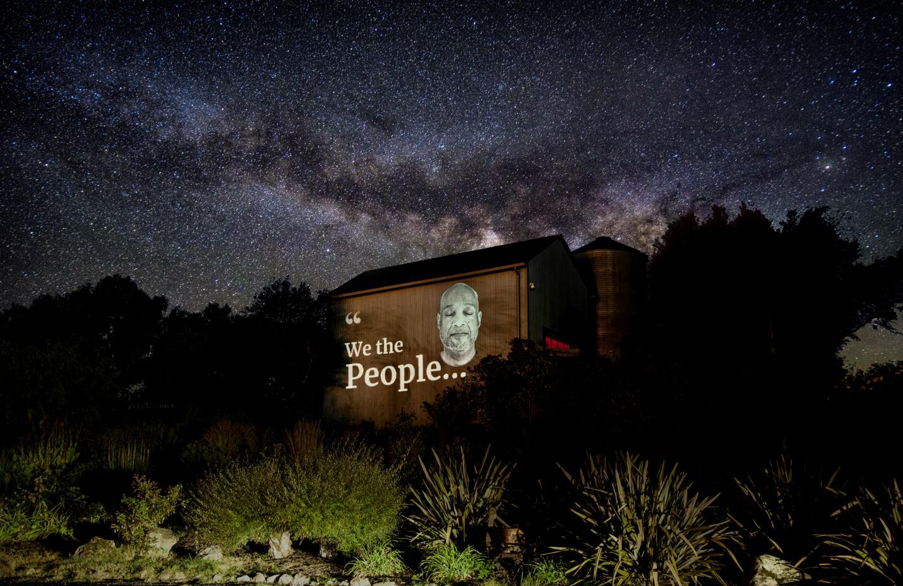
Photo credit: Jock McDonald

